SOP: User Management, AFD and Project Category
Module | User Management, AFD and Project Category
Who uses it | Admin, Super Admin (and users given User Creation permission)
Version | 1.0
Issued | 21 Oct 2026
Screenshots are taken from the HRMS test copy. Names, dates and numbers are examples only.

1. Purpose
Admins create and maintain user accounts, and the QC error lists (AFD) and project categories that decide what QA can mark on the QC form and how much each error costs.
Admins also use: SOP - Manager - Reports (Overview, Billable Report, QA Report, User Monthly Goal, KRA, Tracker Report and Task EOD Report), SOP - Manager - Projects and Tasks, SOP - Manager - QC Report Overview and QA Audit, SOP - Admin - Roster and SOP - Admin - SOP Library.

2. User Management
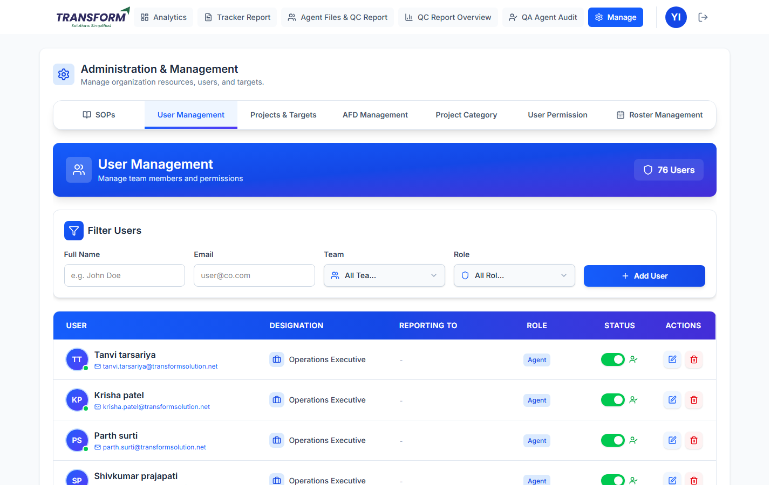
Figure 1: User Management
Part | What it does
Filter Users | Full Name, Email, Team and Role filters.
Add User | Create a new account.
Table | User (name, email), Designation, Reporting To, Role, Status switch (active / inactive) and Actions (edit, delete).

2.1 Create a user
1. Click Add User. Fill Full Name, Email Address, Role, Designation and Password (required). Phone, Address and Profile Picture are optional.
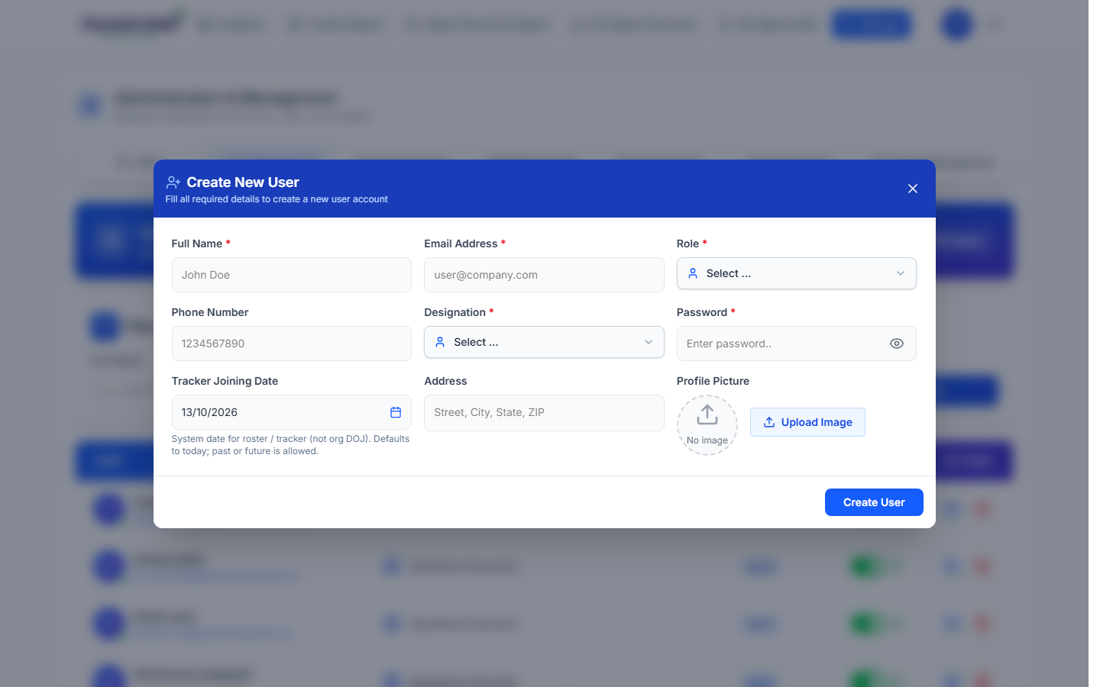
Figure 2: Create New User
2. Choosing the Role shows the extra fields that role needs (see the table below).
3. Tracker Joining Date is the date the person starts using the roster and tracker (not the company joining date). It defaults to today; past or future dates are allowed.
4. Click Create User.
Role | Extra fields
Super Admin, Admin | None (no reporting line or team).
Project Manager | Team (optional).
Assistant Manager | Team (required), Project Manager (optional).
Assistant Team Leader | Team (required), Project Manager and Assistant Manager (optional).
QA | Team, Tenure and Tracker Joining Date (required); PM, AM, Team Leader (optional).
Agent | Team, Quality Analyst, Tenure and Tracker Joining Date (required); PM, AM, Team Leader (optional).

2.2 Edit, deactivate or delete a user
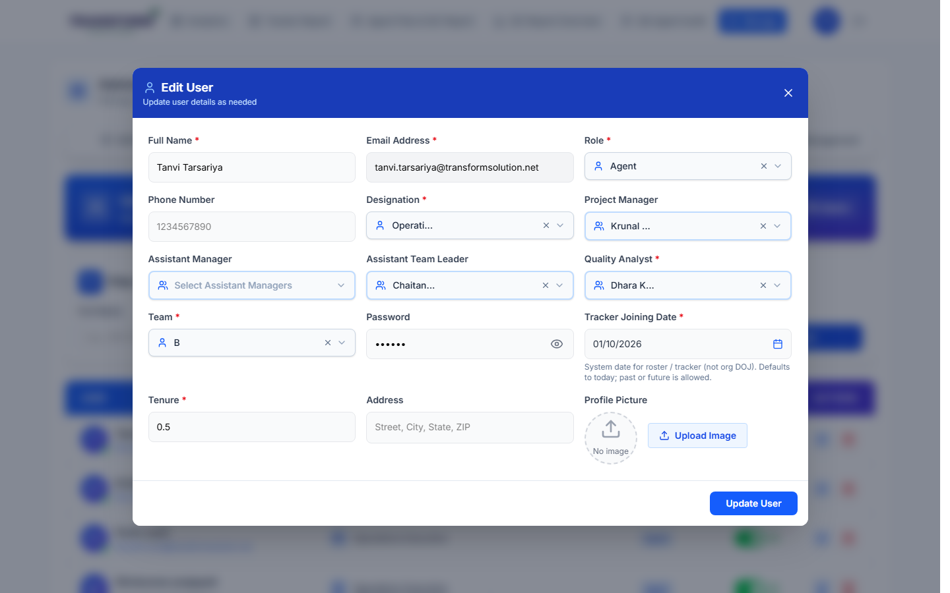
Figure 3: Edit user
- Pencil: edit details. Tenure scales the agent's target (target = task target x tenure).
- Status switch: deactivate someone who has left. They cannot log in and drop out of lists; history stays.
- Bin: delete an account created by mistake.

3. AFD Management (QC error lists)
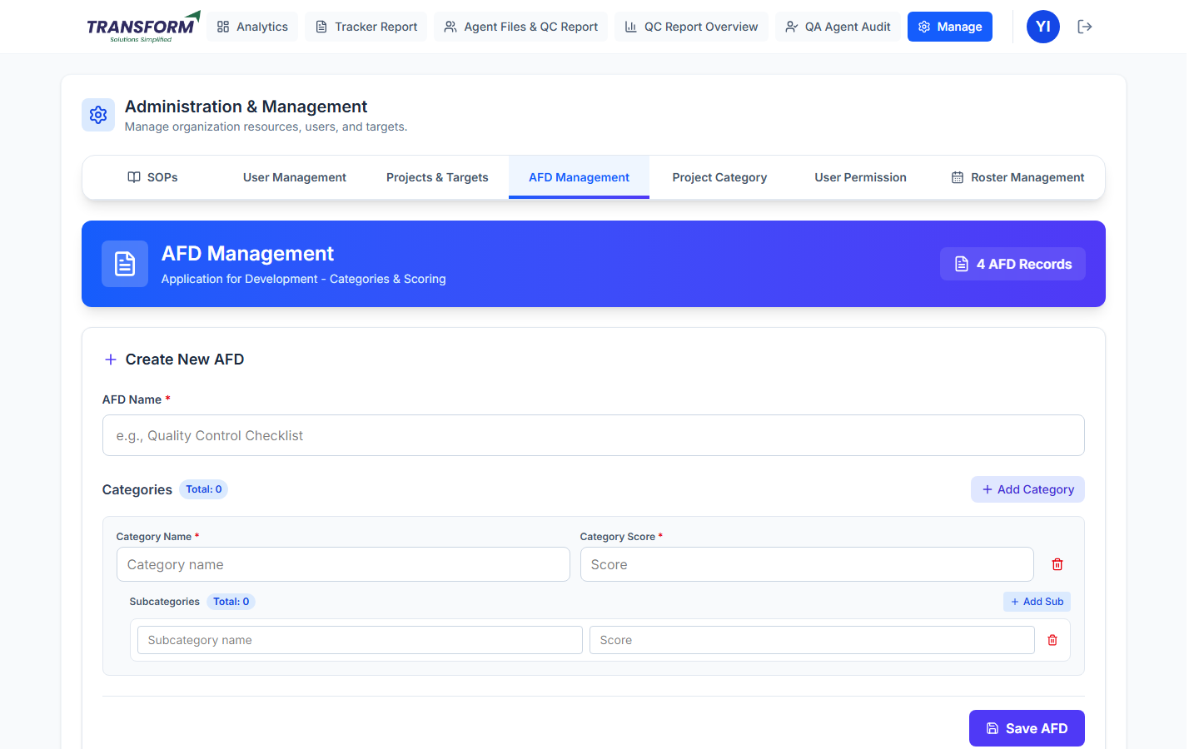
Figure 4: Create New AFD
1. Enter the AFD Name (for example 'AFD for Research').
2. Add Category: enter the Category Name and Category Score. Inside it, Add Sub for each error with its points (how much the error takes off).
3. Add more categories as needed and click Save AFD.
4. Saved AFDs are listed below with their categories and errors. Use the pencil to edit and the bin to remove a category, an error or the AFD.
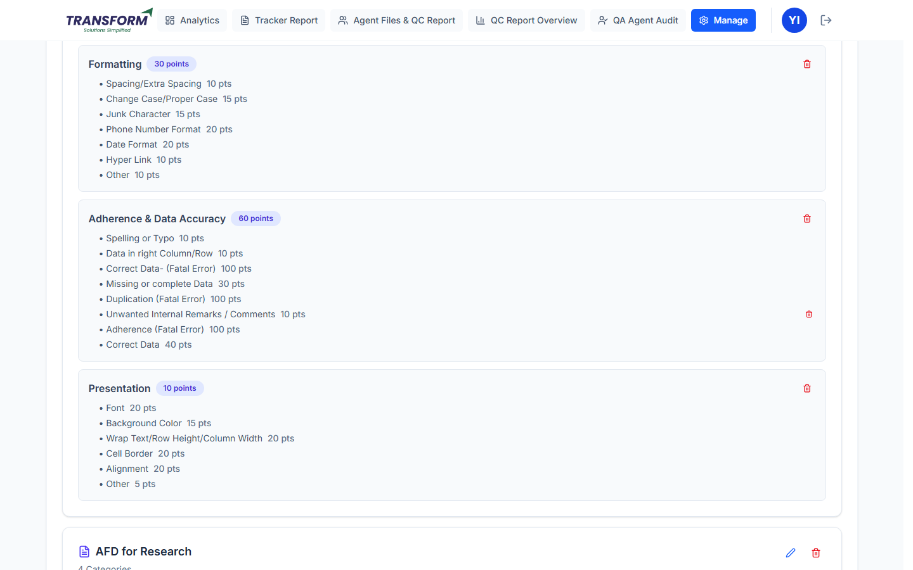
Figure 5: Saved AFD with categories and errors
An error worth 100 points or more is a fatal error: the record it is marked on scores 0.

4. Project Category
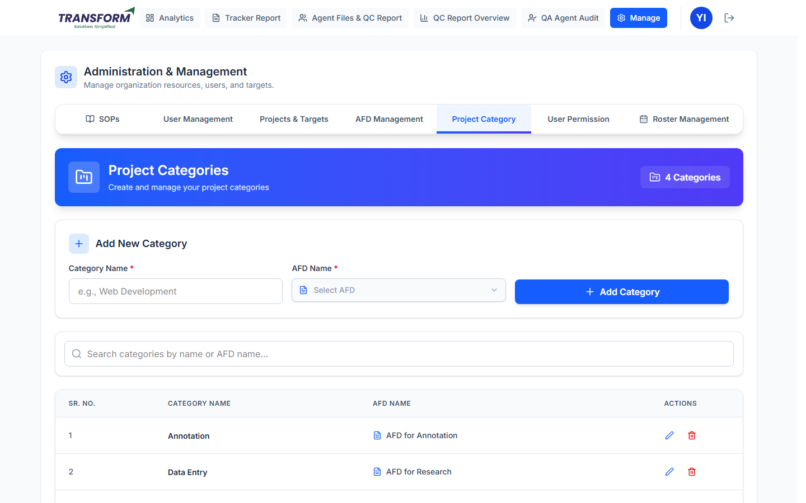
Figure 6: Project Categories
1. Enter the Category Name, choose the AFD Name and click Add Category.
2. Search categories; edit or delete with the icons.
3. Set this category on each project (Edit Project > Project Category). QA then sees this AFD's errors on the QC form for that project.

5. Common problems
Problem | What to do
Agent missing in rosters / tracker | Check the user is active, the role is Agent and the Tracker Joining Date is set.
Target looks wrong | Check the user's Tenure.
QA sees no errors on the QC form | Link the project's category to an AFD.

